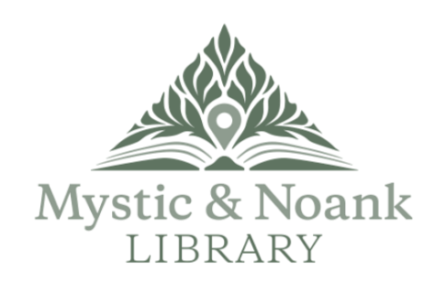

Borrowers’ Services Head--Mystic & Noank Library

The Mystic & Noank Library aspires to support the intellectual, creative, and cultural interests of our library community and visitors. We are a well-supported and welcoming community anchor serving our local communities now and in the future. We value collaboration, accountability, teamwork, and stellar service.

The ideal candidate must be a team player who is innovative, self-motivated, reliable and flexible, with strong technology skills, a positive attitude, and a strong public service work ethic. Prior public library experience, especially with the SirsiDynix catalog, desired.

This is a full-time salaried position, 35 hours per week, with some evening and weekend hours on a regular rotation. It includes vacation and sick time, pension contribution, and Town of Groton medical and dental insurance. Salary range is $40,000 to $50,000, depending on experience.

Interested candidates should submit a cover letter and resume to:

[rdonahue@mysticnoanklibrary.org](mailto:rdonahue@mysticnoanklibrary.org).

See here for full job description.

Position is open until filled.